Task on S3
- Create an S3 bucket and upload some objects to S3.
Create a bucket
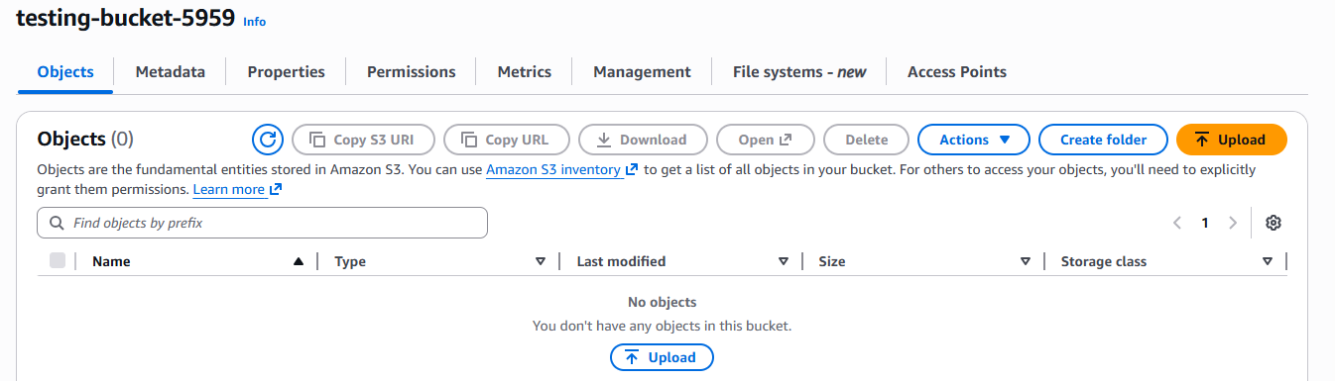
Upload a sample file test.txt
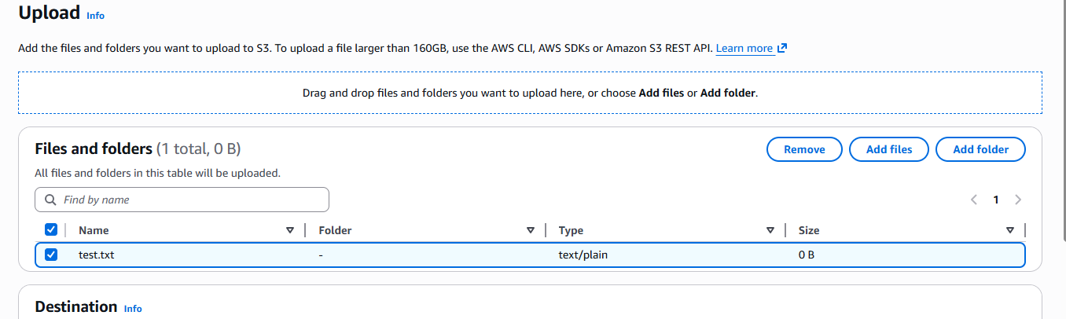
Here we can see the file was uploaded
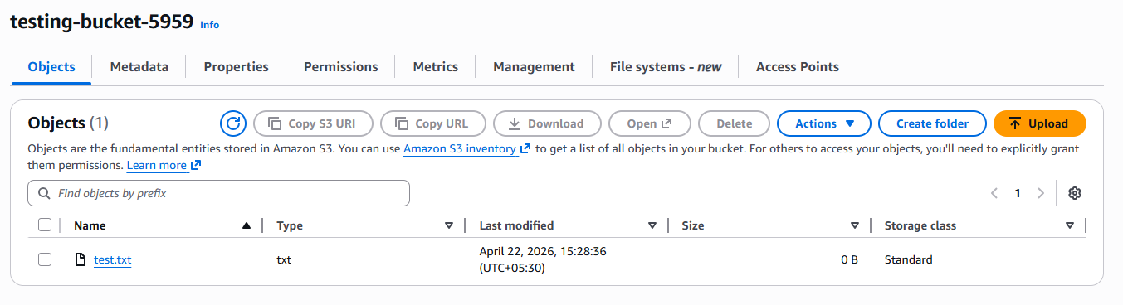

- Deploy a static website in the S3 bucket.
Add index.html fime
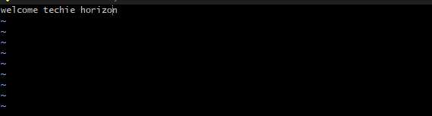
Add file to the bucket
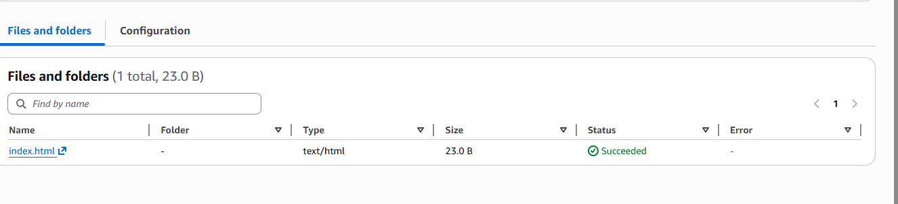
Edit block public access in permissions tab
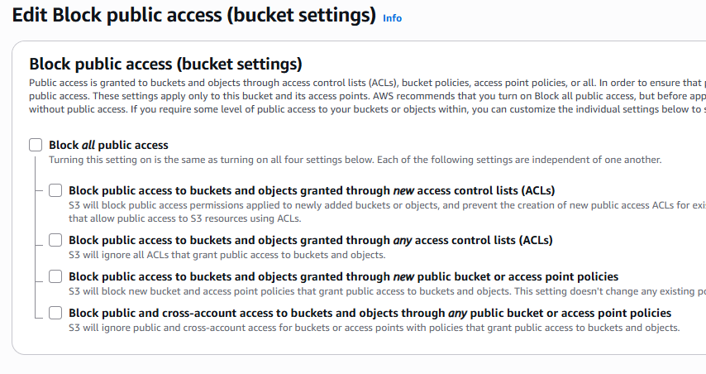

Add a bucket policy
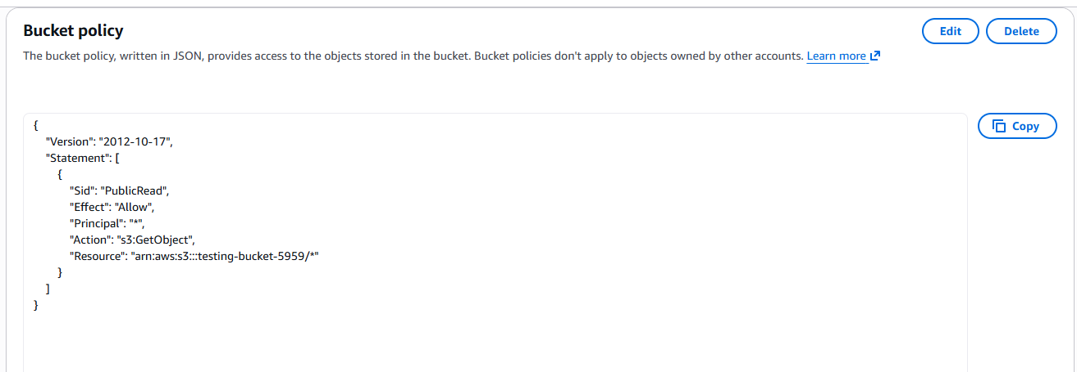
Enable static web hosting in permissions tab
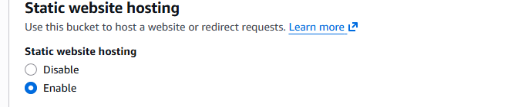
Add the index.html file and save the changes
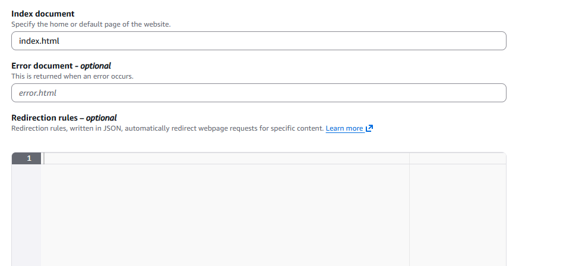

And copy the URL , hit the browser
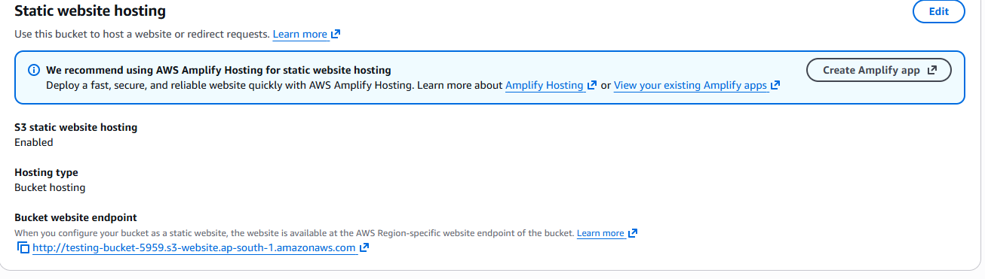
You can see the static page which we are add file(index.html)
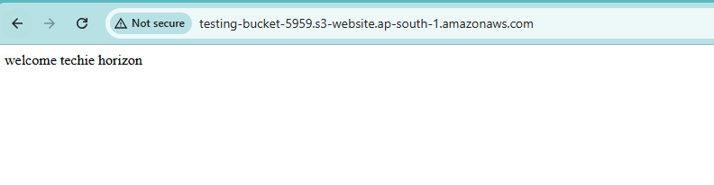
- Enable cross-region replication on S3 buckets.
Creating two buckets with different region
Enable the bucket versioning in the both bucket
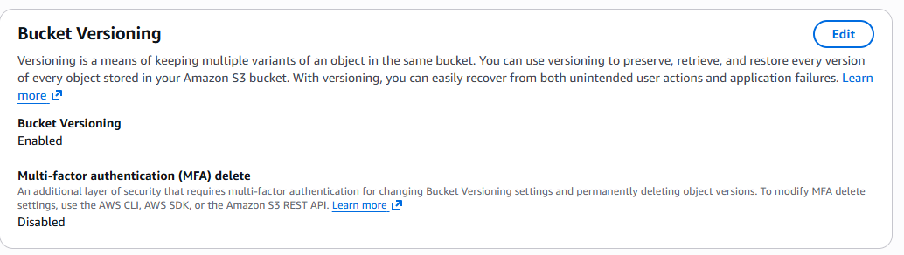

Open Replication Settings
- Go to Source bucket
- Click Management tab
- Scroll to Replication rules
- Click Create replication rule

Configure Replication Rule
🔹 Rule Name
- Enter: crr-rule

🔹 Source
- Apply to:
  - ✅ Entire bucket (or choose prefix if needed)

🔹 Destination
- Choose:
  - ✅ Destination bucket
- Select:
  - my-destination-bucket
- Account:
  - Same account (or cross-account if needed)

🔹 IAM Role
- Select:
  - ✅ Create new role (recommended)
👉 AWS automatically creates required permissions
Click the save
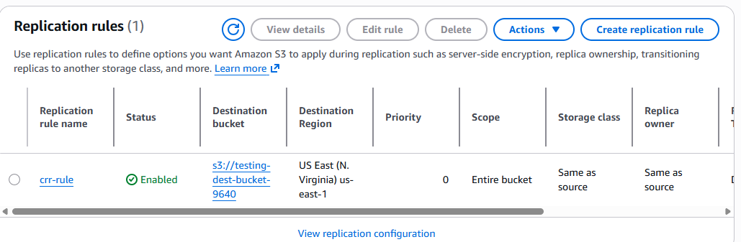
Here we can copy the file source bucket to destination bucket
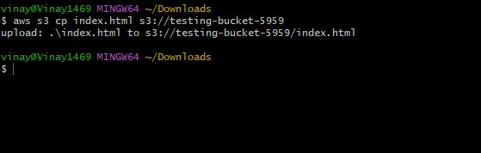
Shows in the aws console also
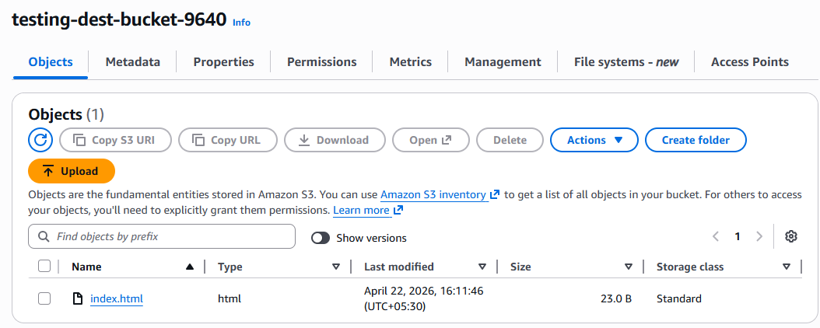

- Configure a bucket policy so only the Admin user can see the objects of the S3 bucket.
Add the bucket policy : only the Admin user can see the objects of the S3 bucket.
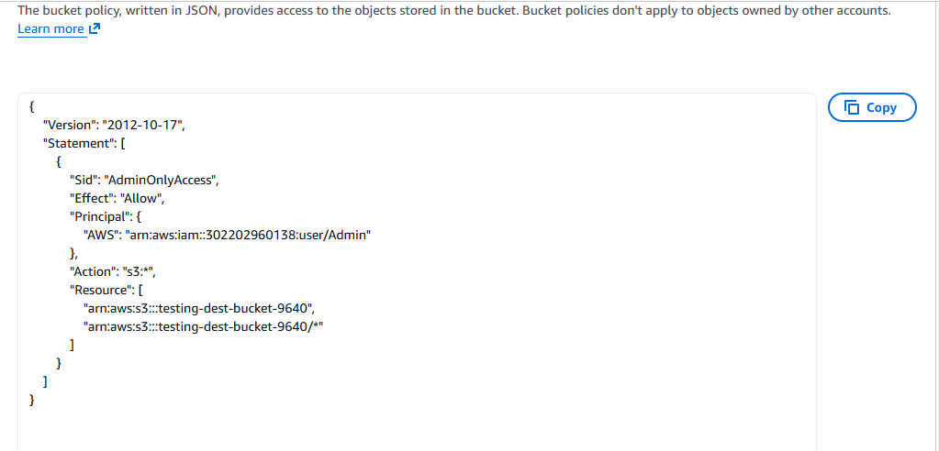
Create a user give the administration access
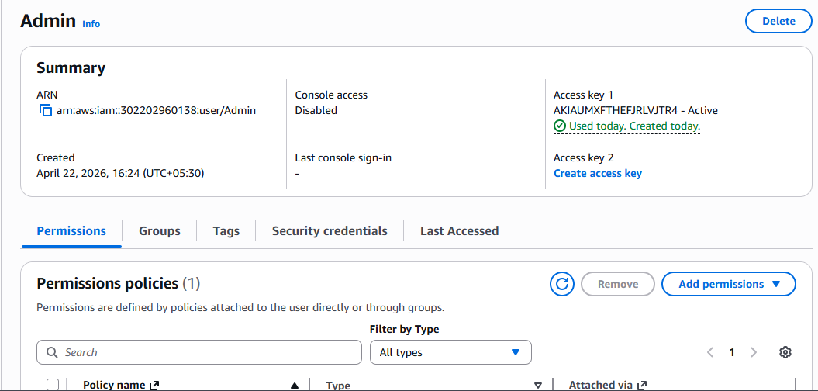

You can CLI with user details and check the buckets
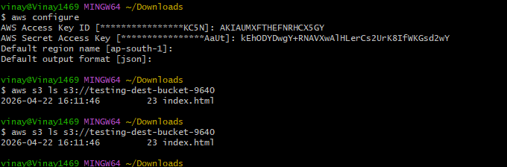

- Set up lifecycle policies to automatically transition or delete objects based on specific criteria.

Open Lifecycle Settings
- Go to AWS Console → S3
- Click your bucket (testing-bucket-9640)
- Go to Management tab
- Scroll to Lifecycle rules
- Click Create lifecycle rule

Define Rule
🔹 Rule Name
- Example: auto-transition-delete

🔹 Scope
Choose:
- ✅ Apply to all objects
(or specify prefix/tags if needed)
Click Next

✅ Step 3: Choose Actions
You’ll see multiple options:
✔ Transition Actions (Cost Optimization)
Enable:
- ✅ Transition current versions of objects
Example:
- Move to Standard-IA after 30 days
- Move to Glacier after 60 days

✔ Expiration Actions (Deletion)
Enable:
- ✅ Expire current versions of objects
Example:
- Delete objects after 90 days

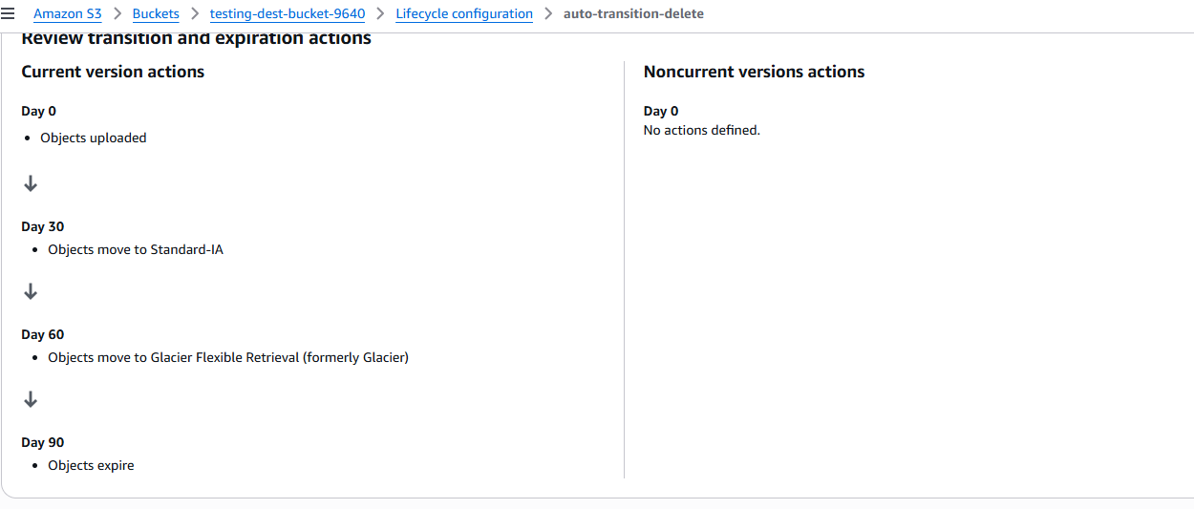

- Push some objects to S3 using the AWS CLI.
Push one file to the bucket by using AWS CLI
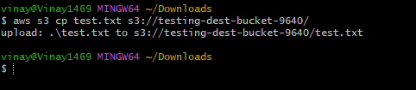
Check in the AWS console
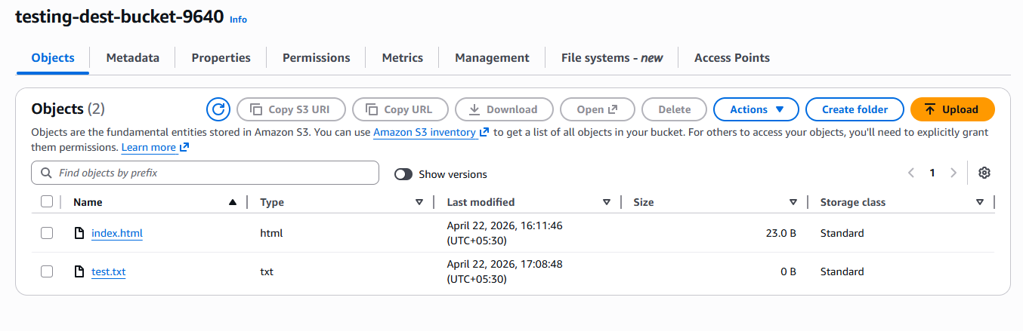
- Write a Bash script to create an S3 bucket.
Write bash script for creating new backet
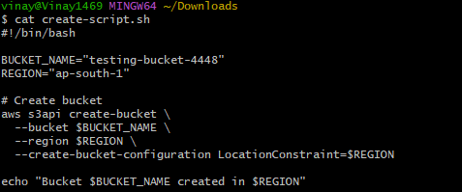

  - Create file and script
  - Change the permission to that file (chmod 755 create-scripts.sh)
  - Run the script(./creat-scripts.sh)
Create bucket called “testing-bucket-4448”

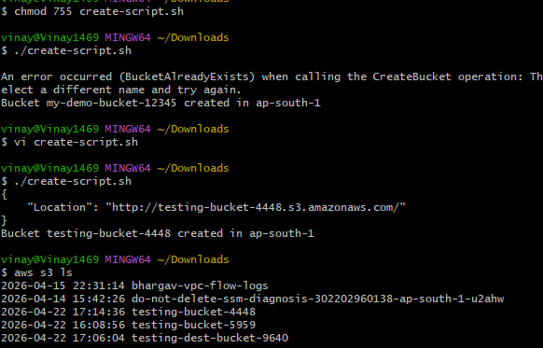
We can check in the AWS console
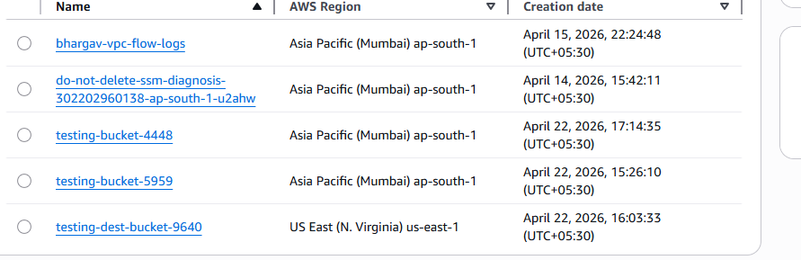

- Upload a 1 GB file to S3 using the CLI.
Here create a 1GB file and upload in s3 bucket
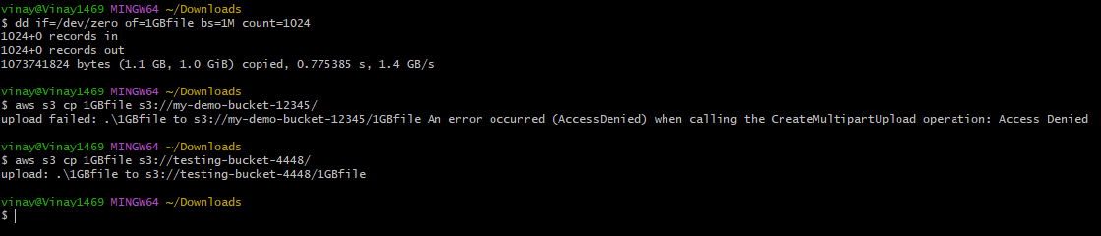
We can in the AWS console also
